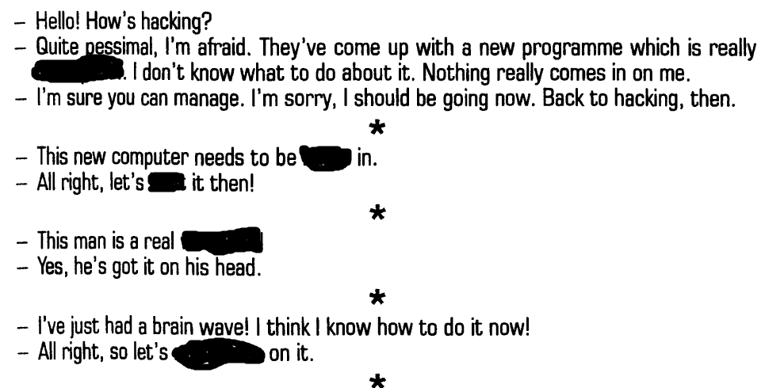

mindshare, bulletproof, boot, burn, wirehead

bulletproof, burn, boot, wirehead, mindshare

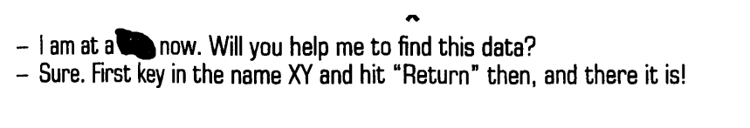

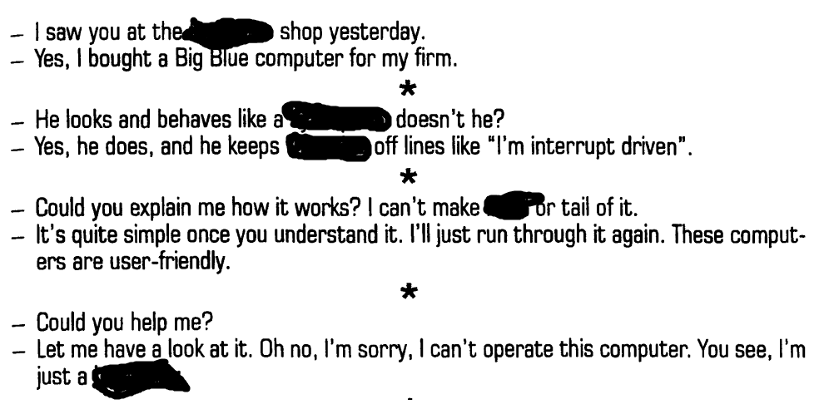

True-blue, hedgehog, cyberpunk, throwing, head, loss

loss, True-blue, cyberpank, throwing, , head, hedgehog

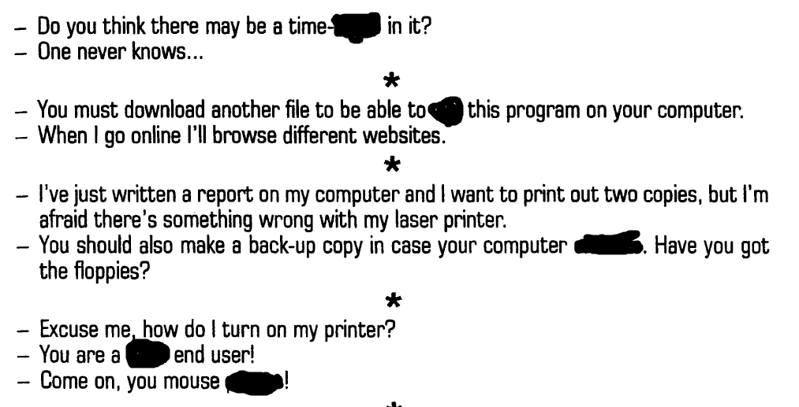



geek, dead, potato, run , bomb, crashes

bomb, run, crashes, dead, potato, geek